NORTHWIND SALES PERFORMANCE DASHBOARD

Submitted By: Pavithra R
Course: B.com (FINTECH AND AI)
Tool Used: Microsoft Power BI Desktop

1. Introduction
For this project, I created an interactive Northwind Sales Performance Dashboard using Microsoft Power BI Desktop. The main purpose of the project was to analyse sales data and present it through simple charts, KPI cards and interactive filters.
The dashboard helps to understand important areas such as sales, orders, customers, quantity sold, freight, product categories and employee-wise orders. It also allows users to interact with the data using filters, drill-through and tooltips.

2. Objectives
The main objectives of this project were:
- To analyse the Northwind sales data.
- To create important sales KPIs using DAX.
- To understand monthly order trends.
- To compare sales between different product categories.
- To analyse employee-wise orders.
- To create an interactive Power BI dashboard.
- To use filters, drill-through and tooltips for better analysis.
- To present business information in a simple and understandable format.

3. Dataset Description
The Northwind dataset contains information related to the company's sales activities. The main tables used in this project were:
- Categories – Contains information about product categories.
- Customers – Contains customer details.
- Employees – Contains employee information.
- Orders – Contains order-related information.
- Order Details – Contains product quantity and sales details.
These tables were connected and used together to create the required calculations and visualizations.

4. Data Preparation
I imported the Northwind dataset into Power BI Desktop and checked the available tables and fields. The main data preparation steps were:
- Checking the data types.
- Checking date and numerical fields.
- Connecting the related tables.
- Creating the required DAX measures.
- Checking the calculations before creating the visuals.
- Ensuring that the data was suitable for creating charts and KPI cards.
This preparation helped ensure that the data was properly organized and ready for analysis.

5. KPI Cards
I created six KPI cards to display the main sales information in a simple and clear format.
KPI | Value
Total Orders | 809
Number of Customers | 91
Total Freight | 63.96K
Total Sales | 1.27M
Total Quantity Sold | 51K
Average Freight | 79.05
These KPI cards provide a quick summary of the overall sales performance and allow users to understand the major business figures at a glance.

6. Visualizations
I created different visualizations to analyse and understand the Northwind sales data.
Total Orders by Month
A line chart was used to show the monthly order trend. It helps identify changes in the number of orders across different months. This visualization makes it easier to observe increases and decreases in order volume.
Total Orders by Employee
A bar chart was used to compare the number of orders associated with different employees. It helps understand the differences in order volume handled by employees.
Total Sales by Category
A column chart was used to compare sales across different product categories. From the visual, Beverages show the highest sales among the categories displayed.
These visualizations make the sales data easier to compare, interpret and understand.
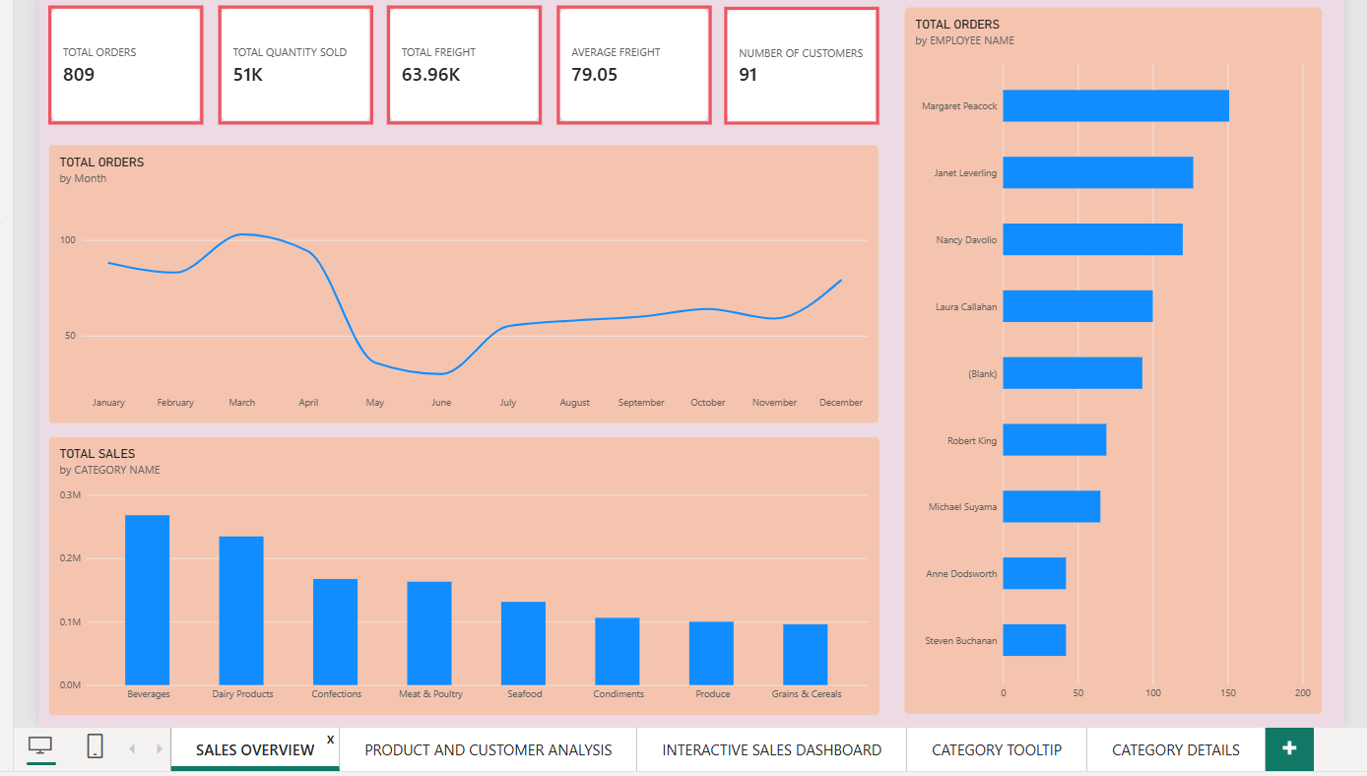

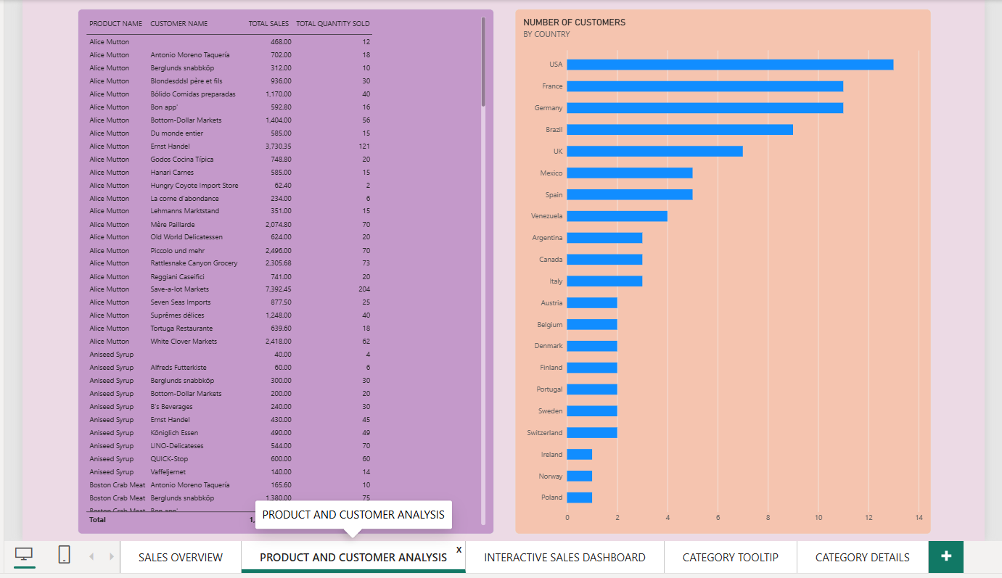

8. KPI Cards – Explanation
The KPI cards were created to present the most important business figures at a glance.
Total Orders – 809:
Shows the total number of orders in the dataset.
Number of Customers – 91:
Shows the number of customers included in the analysis.
Total Freight – 63.96K:
Shows the total freight amount associated with the orders.
Total Sales – 1.27M:
Shows the total sales generated from the Northwind data.
Total Quantity Sold – 51K:
Shows the total quantity of products sold.
Average Freight – 79.05:
Shows the average freight value of the orders.
Purpose of KPI Cards
I used KPI cards because they provide a quick overview of the business performance. Users can understand the main figures without analysing every individual chart. This makes the dashboard simple, clear and easy to use.

9. Drill Through
I created a separate Drill Through page for detailed analysis. The drill-through feature allows the user to move from a summary-level visual to more detailed information based on the selected data.
For example, users can select a particular category or employee from the main dashboard and view more detailed information on the drill-through page.
This feature makes the report more interactive and helps users analyse specific information in greater detail.
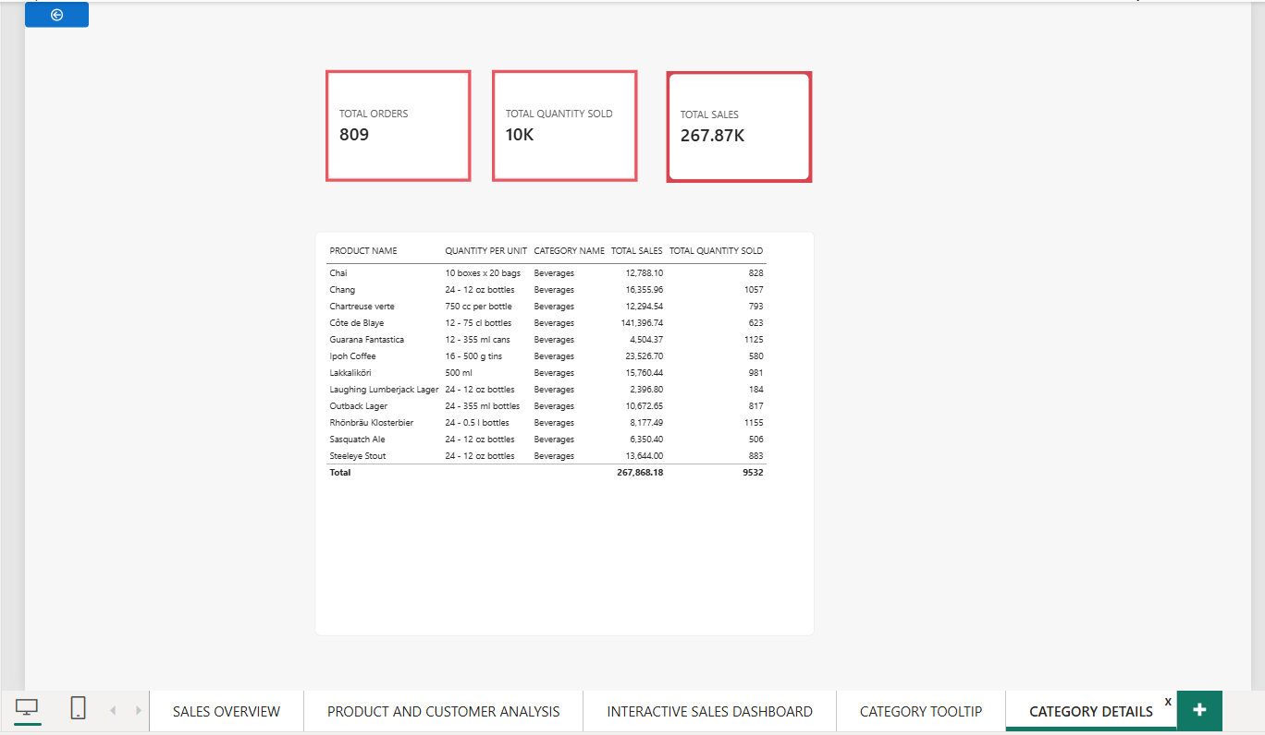

10. Sales Tooltip
I created a separate Sales Tooltip page to provide additional information when the user interacts with a visual.
The tooltip displays extra information without adding too many details to the main dashboard. This keeps the dashboard clean and simple while still allowing users to access additional information when required.
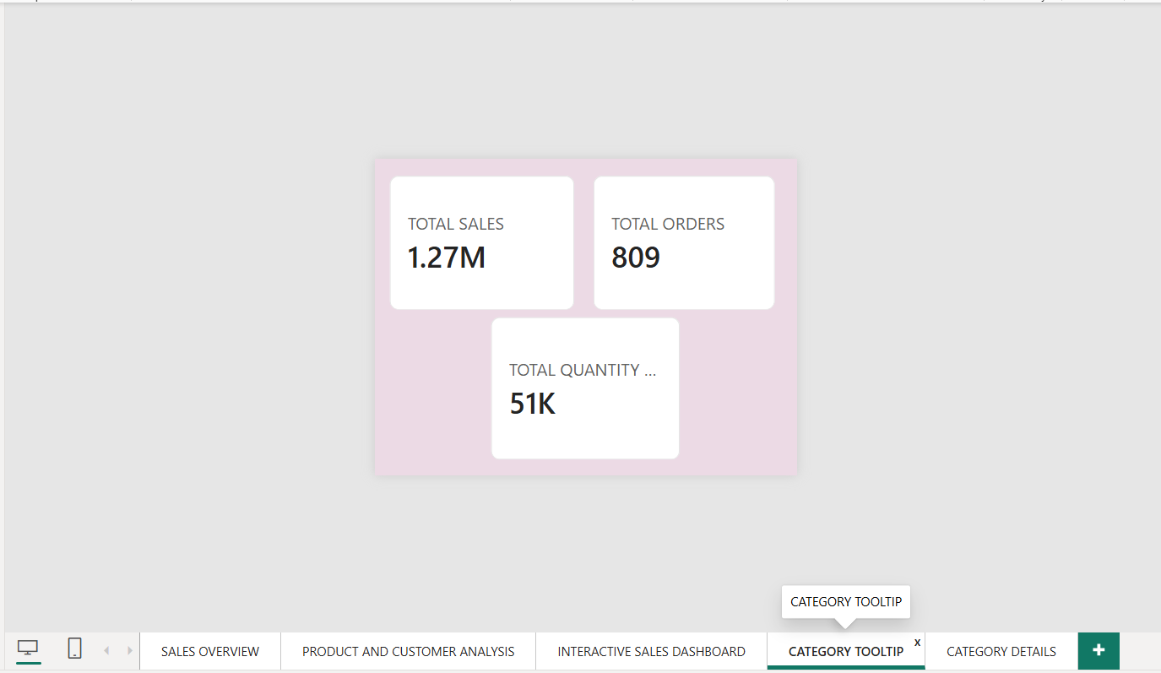

11. Dashboard and Filters
The final dashboard combines the important KPI cards and visualizations into one interactive page.
The dashboard includes:
- Total Orders by Month
- Total Orders by Employee
- Total Sales by Category
- KPI Cards
- Interactive Filters
- Drill Through
- Sales Tooltip
I added three main filters:
- Year
- Region
- Category Name
These filters allow users to select specific data and analyse the dashboard according to their requirements.
For example, selecting a particular category can help analyse the sales performance of that product category. Similarly, the Year and Region filters help users narrow down the analysis and focus on specific areas.
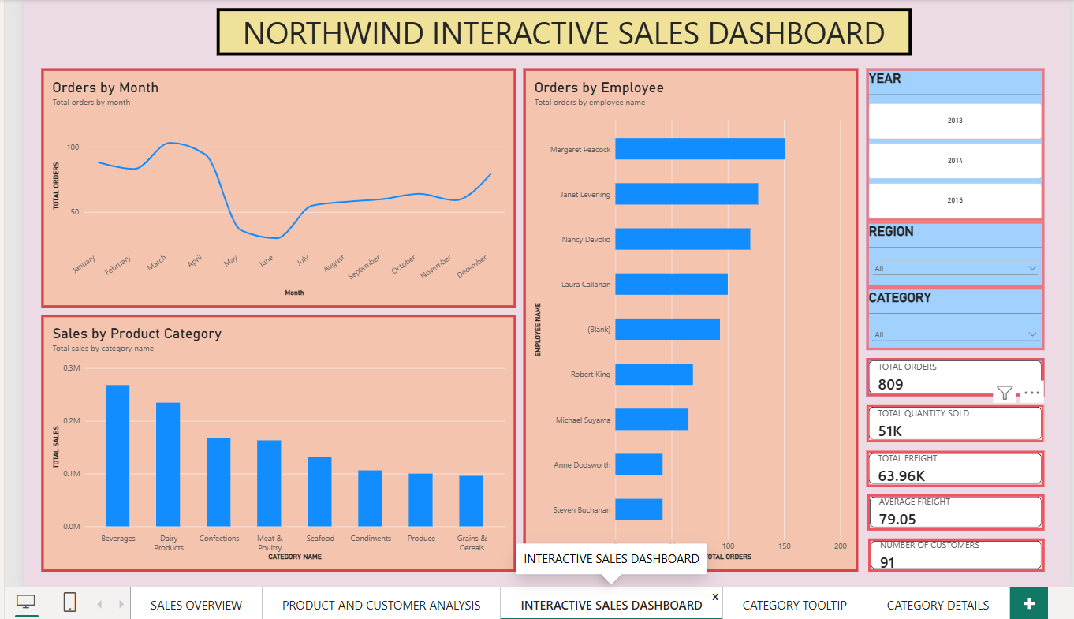

12. Key Findings
From the completed dashboard, I observed the following key findings:
- Total sales are 1.27M.
- There are 809 total orders.
- The dataset contains 91 customers.
- Around 51K quantity of products was sold.
- Total freight is 63.96K.
- Average freight is 79.05.
- Beverages have the highest sales among the categories displayed.
- Order volume changes across different months.
- Employee-wise order volumes are different.
- The dashboard provides a clear view of overall sales performance.
- The filters make it easier to analyse the data based on Year, Region and Category Name.
- Drill-through provides additional details for deeper analysis.
- Tooltips provide extra information without making the main dashboard crowded.

13. Conclusion
This project helped me understand how Microsoft Power BI can be used to convert sales data into meaningful business information. Through this project, I learned how to prepare data, create DAX measures, validate calculations, create KPI cards and design different types of visualizations.
The final Northwind Sales Performance Dashboard provides a simple and interactive way to understand sales, orders, customers, product categories, freight and employee performance. The use of filters, drill-through and tooltips made the report more interactive and useful for business analysis.
Overall, this project improved my practical knowledge of Power BI, DAX, data visualization and business analytics.

14. References
- Microsoft Power BI Desktop
- Northwind Sales Dataset
- Microsoft Power BI Documentation

